
ASSIGNMENT 1

V.MOUNIKA G4-25-VLSI
THE DOMAIN OF THE PROJECT
PHYSICAL DESIGN


BASIC LINUX COMMANDS

Command | Purpose | Example
pwd | Show current directory | pwd
ls | List files/folders | ls
ls -l | Detailed file list | ls -l
ls -a | Show hidden files | ls -a
cd | Change directory | cd Documents
cd .. | Go back one folder | cd ..
cd ~ | Go to home directory | cd ~
mkdir | Create folder | mkdir project
rmdir | Remove empty folder | rmdir test
touch | Create empty file | touch file.txt
cat | View file content | cat file.txt
cp | Copy file | cp a.txt b.txt
mv | Move/Rename file | mv a.txt newa.txt
rm | Delete file | rm a.txt
clear | Clear terminal | clear
history | Show command history | history


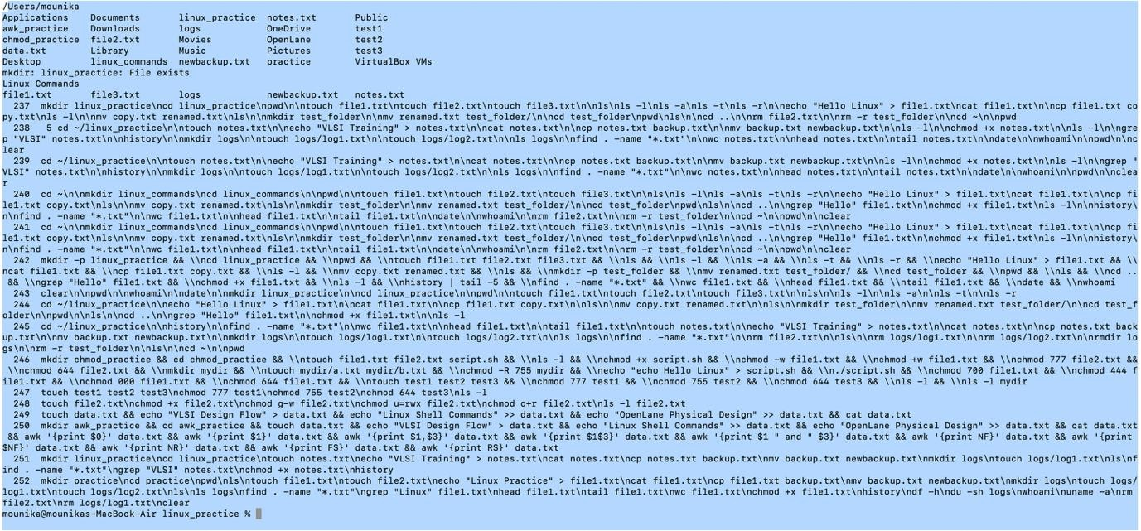
File Viewing Commands
Linux File Viewing Commands:

 |  |  |  |  | Purpose | Example | What it does
Command
cat |  |  |  |  | View full file content | cat file.txt | Displays entire file at once
less |  |  |  |  | Scrollable file view | less file.txt | Open file with up/down scrolling  (q to exit)
more |  |  |  |  | Page-by-page view | more file.txt | Shows file one screen at a time
head |  |  |  |  | First lines of file | head file.txt | Shows first 10 lines
head -n 5 |  |  |  |  | First 5 lines | head -n 5  file.txt | Shows only first 5 lines
tail |  |  |  |  | Last lines of file | tail file.txt | Shows last 10 lines
tail -n 5 |  |  |  |  | Last 5 lines | tail -n 5  file.txt | Shows only last 5 lines
wc |  |  |  |  | Count  lines/words/bytes | wc file.txt | Shows line, word, character count
wc -l |  |  |  |  | Count lines only | wc -l file.txt | Shows number of lines
wc -w |  |  |  |  | Count words only | wc -w file.txt | Shows number of words
wc -c |  |  |  |  | Count characters | wc -c file.txt | Shows number of characters
grep |  |  |  |  | Search text in file | grep "VLSI"  file.txt | Finds matching lines
file |  |  |  |  | Check file type | file file.txt | Shows file format/type


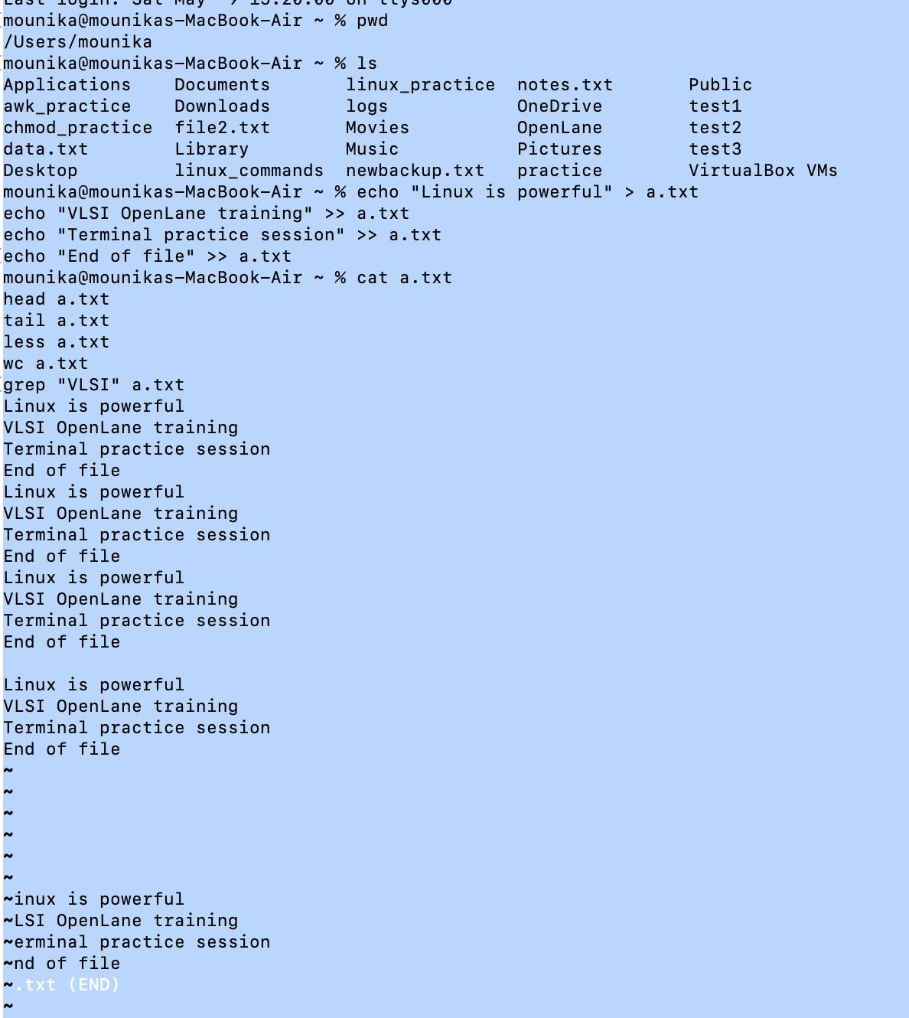


Linux Search Commands

Command | Purpose | Example | What it does
grep | Search text inside files | grep "VLSI" file.txt | Finds matching lines in a file
grep -i | Case-insensitive search | grep -i "vlsi" file.txt | Matches VLSI, vlsi, Vlsi etc.
grep -r | Search in all files (recursive) | grep -r "OpenLane" . | Searches inside all files in folder
find | Search files/folders by name | find . -name "file.txt" | Finds file in current directory tree
find / - name | Search system-wide | find / -name "*.txt" | Finds all .txt files in system
locate | Fast file search (database- based) | locate file.txt | Quickly finds file path
which | Find command location | which python3 | Shows where command is installed
whereis | Find binary/source/docs | whereis gcc | Shows locations of program files
awk | Pattern-based search + extract | awk '{print $1}' file.txt | Extracts columns/fields
sed | Search & replace text | sed 's/Linux/Unix/' file.txt | Replaces words in file

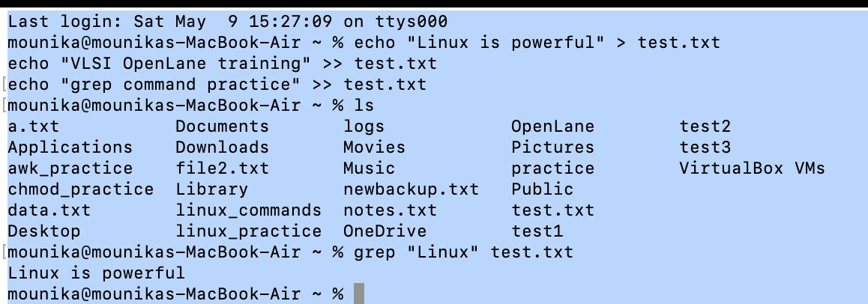



Linux File Permission Commands

Command | Purpose | Example | What it does
ls -l | View permissions | ls -l file.txt | Shows read/write/execute permissions
chmod | Change permissions | chmod 755 file.sh | Sets file access rights
chmod +x | Add execute permission | chmod +x script.sh | Makes file executable
chmod -x | Remove execute permission | chmod -x script.sh | Removes execute right
chmod u+rwx | User permissions | chmod u+rwx file.txt | Gives read/write/execute to owner
chmod g+r | Group permission | chmod g+r file.txt | Gives read access to group
chmod o+r | Others permission | chmod o+r file.txt | Gives read access to others
chmod 777 | Full permission | chmod 777 file.txt | Everyone can read/write/execute
chmod 644 | Common safe file permission | chmod 644 file.txt | Owner full, others read only
chmod 755 | Common script permission | chmod 755 script.sh | Owner full, others execute
chown | Change file owner | chown user file.txt | Changes file ownership
chgrp | Change group | chgrp dev file.txt | Changes group ownership

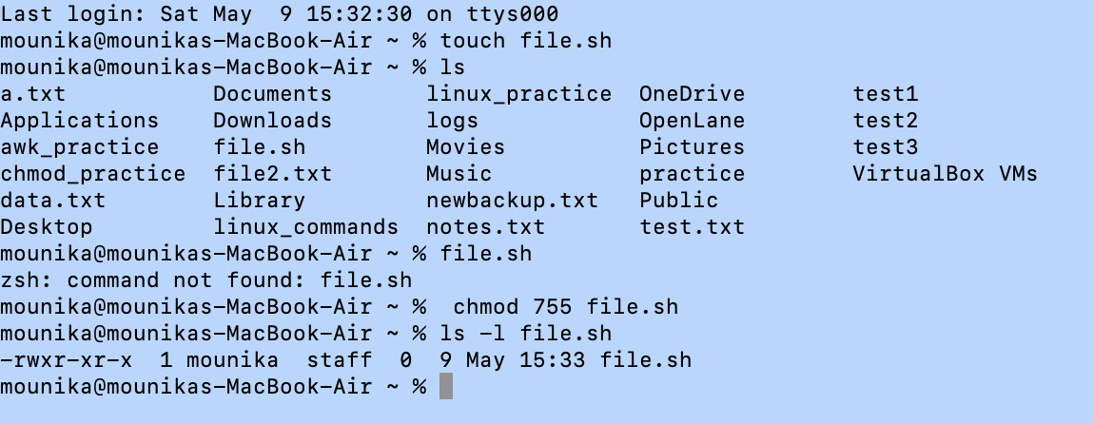



Permission Numbers Explained

Number | Meaning
4 | Read (r)
2 | Write (w)
1 | Execute (x)

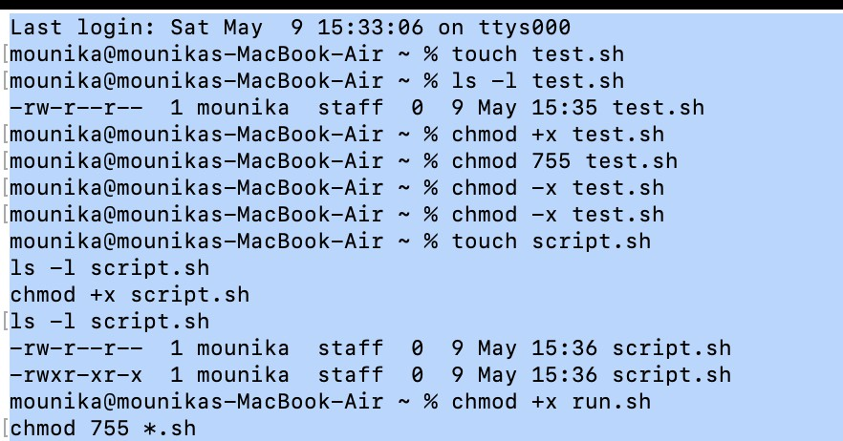


awk Commands

awk is a powerful text-processing tool (commonly used in Linux/Unix) for scanning and manipulating structured text, especially column-based data.

Command | Purpose | Example
awk '{print}' file | Print entire file | awk '{print}' data.txt
awk '{print $1}' file | Print 1st column | awk '{print $1}' data.txt
awk '{print $1, $2}' file | Print multiple columns | awk '{print $1, $2}' data.txt
awk -F',' '{print $1}' file | Set comma as separator | awk -F',' '{print $1}' data.csv
awk '{print NR, $0}' file | Print line numbers | awk '{print NR, $0}' data.txt
awk '/text/ {print}' file | Search pattern | awk '/error/ {print}' log.txt
awk '$2 > 50 {print}' file | Condition filter | awk '$2 > 50 {print}' data.txt
awk 'BEGIN {print "Start"}  {print} END {print "End"}' file | Before & after processing | awk 'BEGIN{print "Start"}  {print} END{print "End"}' file.txt
awk '{sum += $1} END {print sum}' file | Sum column values | awk '{sum += $1} END {print sum}' data.txt
awk '{count++} END {print count}' file | Count lines | awk '{count++} END {print count}' file.txt
awk '{print $NF}' file | Print last column | awk '{print $NF}' data.txt
awk '{sub("old","new"); print}' file | Replace first match | awk '{sub("a","A"); print}' file.txt
awk '{gsub("old","new"); print}' file | Replace all matches | awk '{gsub("a","A"); print}' file.txt
awk 'NR > 1 {print}' file | Skip first line | awk 'NR > 1 {print}' file.txt
awk -v x=10 '$1 > x {print}' file | Use variable | awk -v x=10 '$1 > x' file.txt
awk '{printf "%s %d\n", $1,  $2}' file | Formatted output | awk '{printf "%s %d\n", $1,  $2}' file.txt


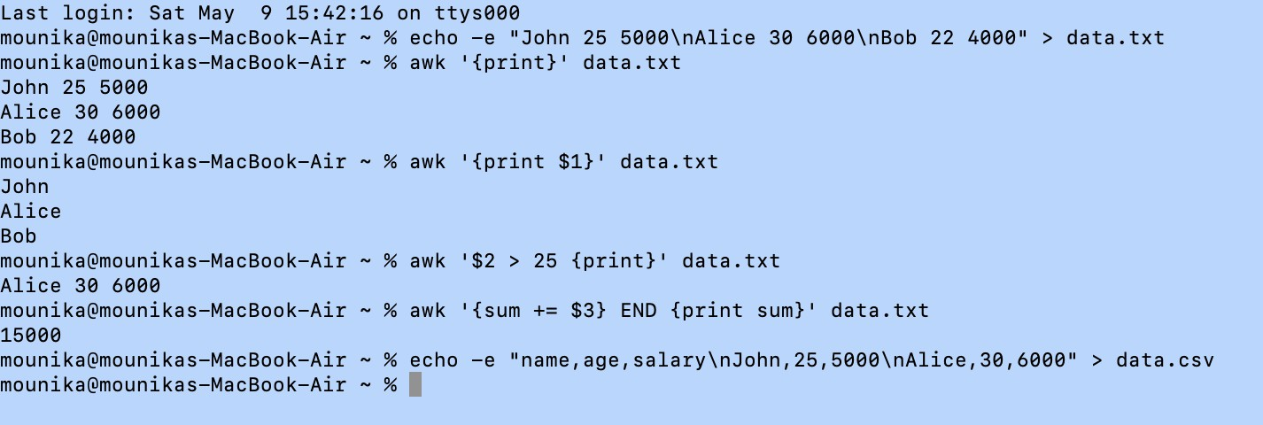
vi / vim Editor Basics

Vim (VI Improved) is a powerful terminal-based text editor used to create and edit files directly in the command line.

VI has 3 main modes

Mode | Purpose | How to enter
Command Mode | Navigate, delete, copy | Default mode
Insert Mode | Write/edit text | Press i
Last-line Mode | Save/quit/search | Press :

Category | Command | Purpose | Example
Open file | vi filename | Open file in VI editor | vi script.awk
Insert mode | i | Start typing text | Press i then type
Exit insert mode | Esc | Return to command mode | Press Esc
Save file | :w | Write (save) file | :w
Quit editor | :q | Exit VI | :q
Save & quit | :wq | Save and exit | :wq
Force quit | :q! | Exit without saving | :q!
Move left | h | Cursor left | H
Move right | l | Cursor right | L
Move down | j | Cursor down | J
Move up | k | Cursor up | K
Go top | gg | First line | Gg
Go bottom | G | Last line | G
Delete line | dd | Remove entire line | Dd
Copy line | yy | Yank (copy) line | Yy
Paste | p | Paste copied text | P
Undo | u | Undo last change | U
Delete character | x | Delete single character | x


Search text | /text | Search inside file | /error
Next match | n | Next search result | n
Previous match | N | Previous search result | N
Save file | :w | Save changes | :w
Swap recovery | :recover | Recover crashed file | :recover file
Open read-only | O | Open safely | Choose O in prompt
Delete swap file | rm *.swp | Remove swap warning | rm .script.awk.swp

chmod (change mode) is a Linux command used to change the permissions of a
file or directory, such as read, write, and execute access for users.

Category | Command | Meaning | Example
Basic use | chmod permissions file | Change file permissions | chmod 755 script.sh
Make executable | chmod +x file | Add execute permission | chmod +x run.sh
Full access (owner only) | chmod 700 file | rwx for user only | chmod 700 file.txt
Read + execute (all) | chmod 755 file | Common for scripts | chmod 755 script.sh
Read/write all | chmod 666 file | Everyone can edit | chmod 666 file.txt
Read only all | chmod 444 file | No write access | chmod 444 file.txt
User permission | chmod u+x file | Add execute to owner | chmod u+x script.sh
Group permission | chmod g+w file | Add write to group | chmod g+w file.txt
Others permission | chmod o-r file | Remove read for others | chmod o-r file.txt
All users | chmod a+x file | Add execute for all | chmod a+x run.sh
Remove execute | chmod -x file | Remove execution | chmod -x script.sh
Numeric mode | chmod 777 file | Full access to all | chmod 777 file.txt


Numeric mode | chmod 644 file | Owner rw, others r | chmod 644 file.txt
Numeric mode | chmod 600 file | Owner rw only | chmod 600 file.txt
Check permission fix | ls -l | View permissions | ls -l script.sh

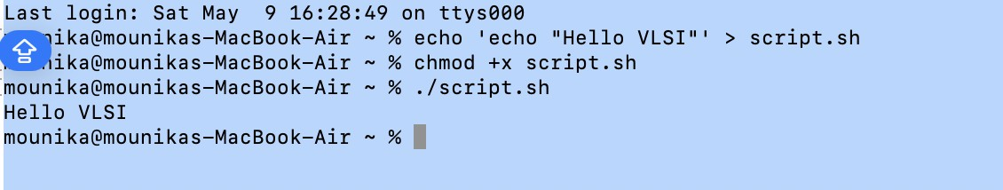
OpenLane

Objective
To run an RTL-to-GDSII digital design flow using OpenLane and understand the complete ASIC design automation process.

Tool Used
  - OpenLane (Docker-based VLSI design flow)
  - Docker environment for running OpenLane flow

Steps Followed
Step 1: Docker Installation
  - Docker was installed on the system to support OpenLane execution.
  - Verified installation using:


docker –version
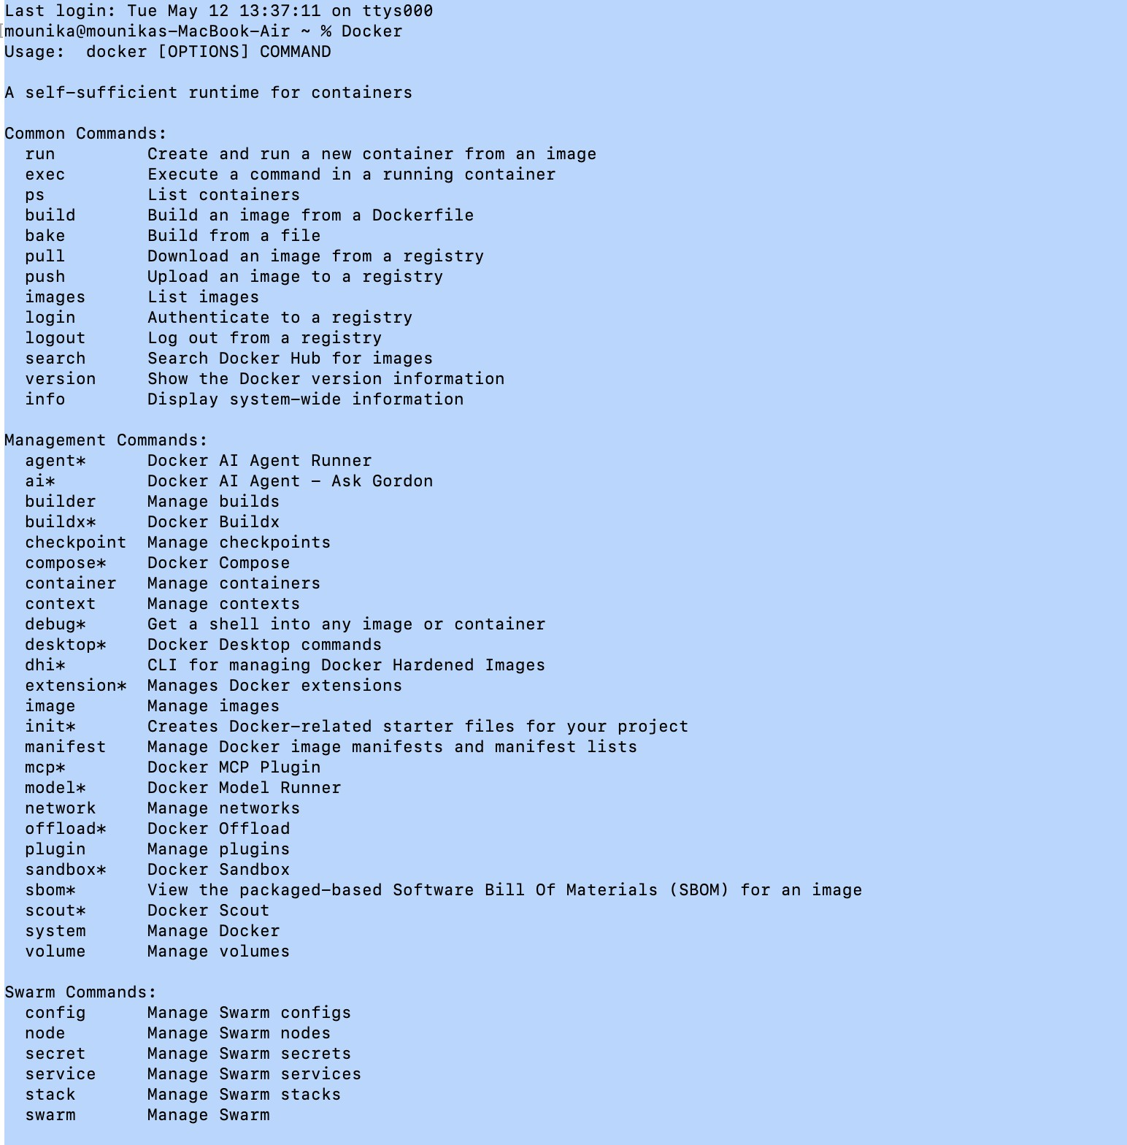


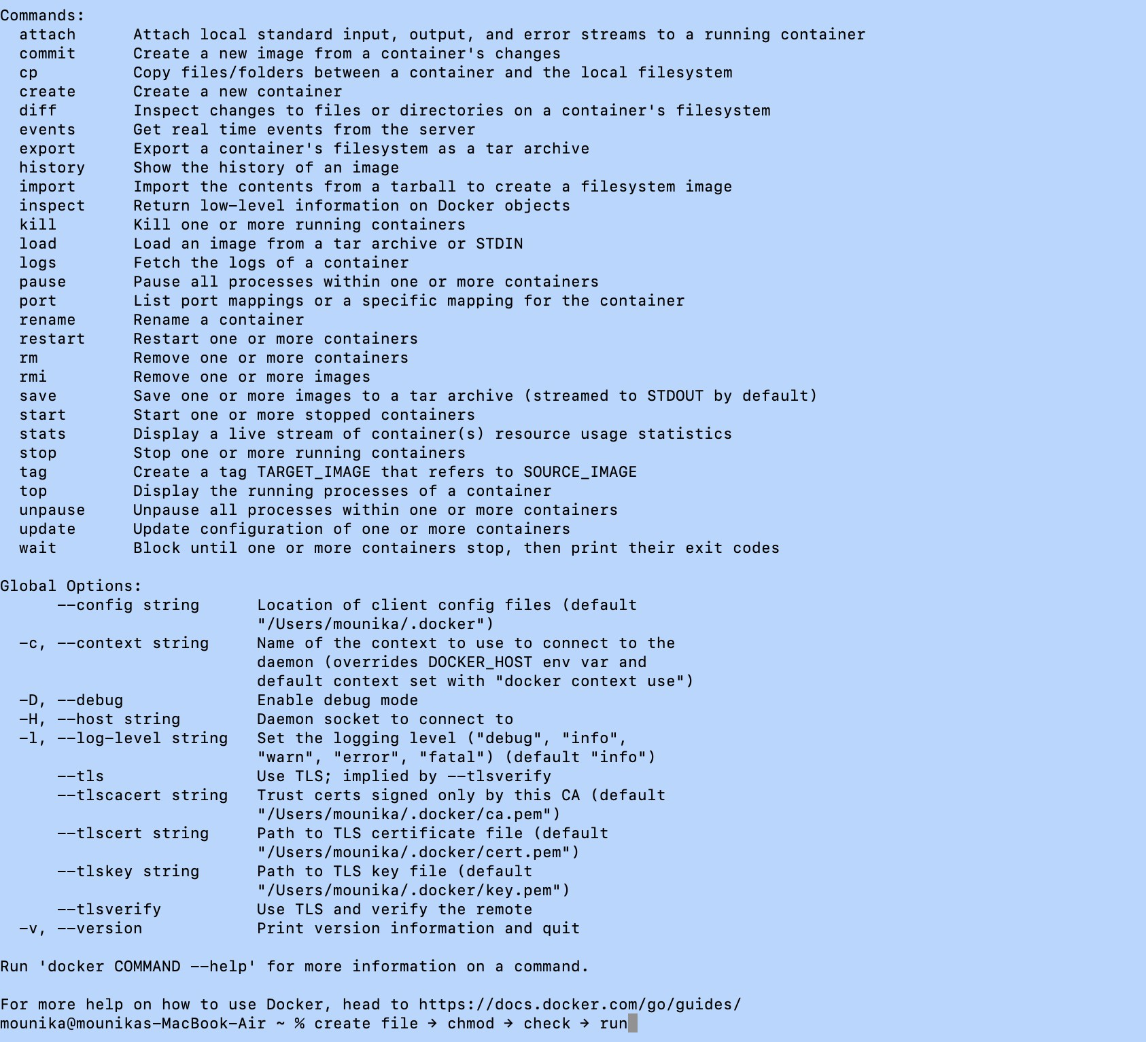

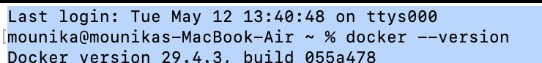



Step 2: Running OpenLane Container
  - OpenLane Docker image was pulled and executed:
docker run -it efabless/openlane:late

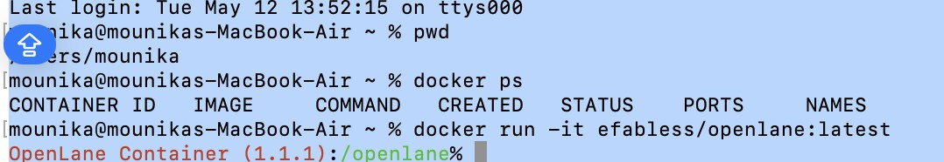

Step 3: Executing RTL-to-GDSII Flow
  - Navigated to OpenLane directory:
cd openlane
  - Ran the design flow using:
./flow.tcl -design picorv32a
  - This executed all stages:
    - Synthesis
    - Floorplanning
    - Placement


    - Clock Tree Synthesis (CTS)
    - Routing
    - GDSII generation

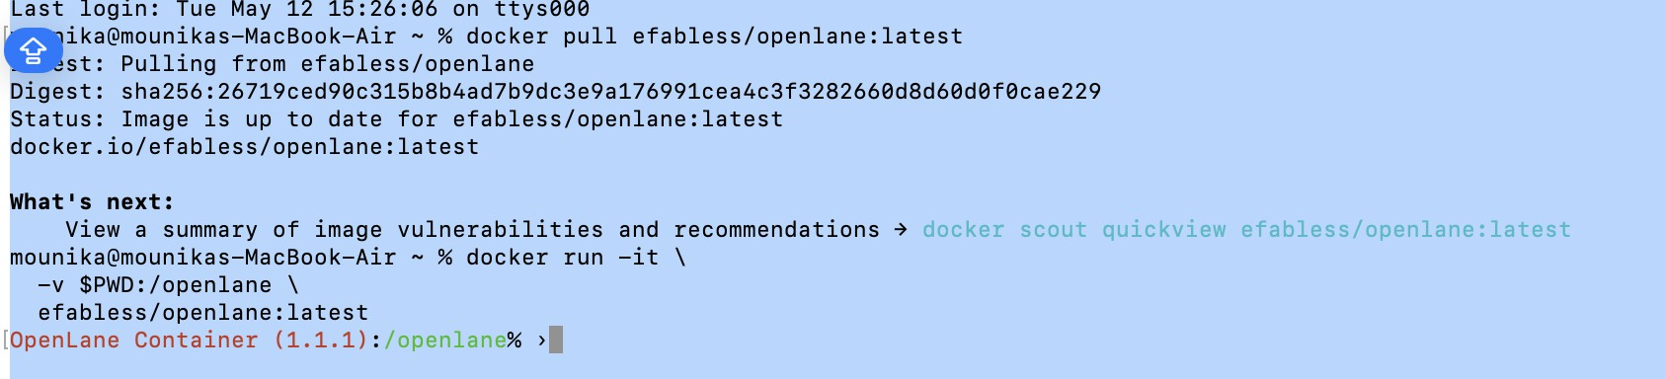

Step 4: Generating Output (GDSII)
  - Final output files were generated inside:
designs/picorv32a/runs/
  - Verified results in:
    - reports/
    - results/
    - logs/
    - final GDSII layout
•

  - ​
  - 4. Result
  - The RTL-to-GDSII flow was successfully executed using OpenLane.
All design stages were completed, and final chip layout files were generated successfully.


Tcl scripting is widely used in VLSI and EDA tools like:
  - OpenLane
  - OpenROAD
  - Vivado
  - Cadence Innovus
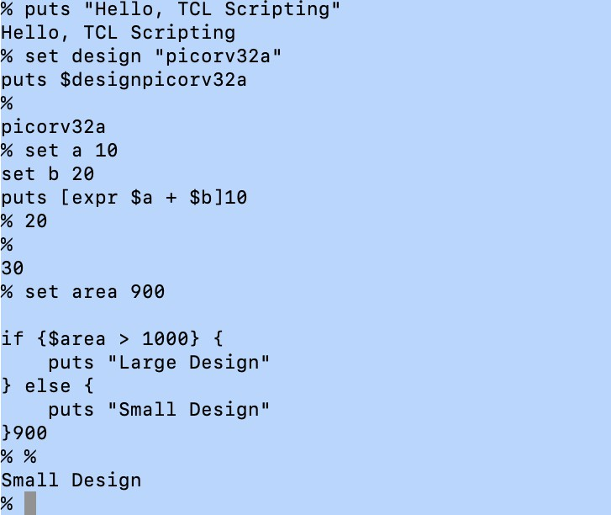


C. TCL Task
- Wire Length Calculation
a. Find out total Wire length, Clock wire length and Data wire length of
design
Method 1- Using Basic commands from 24-wire_lengths.csv file
- Total wire length: 1500
awk -F',' '{sum += $2} END {print sum}' 24-wire_lengths.csv
- Clock wire length: 300
grep -i clk 24-wire_lengths.csv | awk -F',' '{sum += $2} END {print sum}'
- Data wire length: 1200
grep -iv clk 24-wire_lengths.csv | awk -F',' '{sum += $2} END {print sum}'
Method 2- Using openroad and Manual calculations

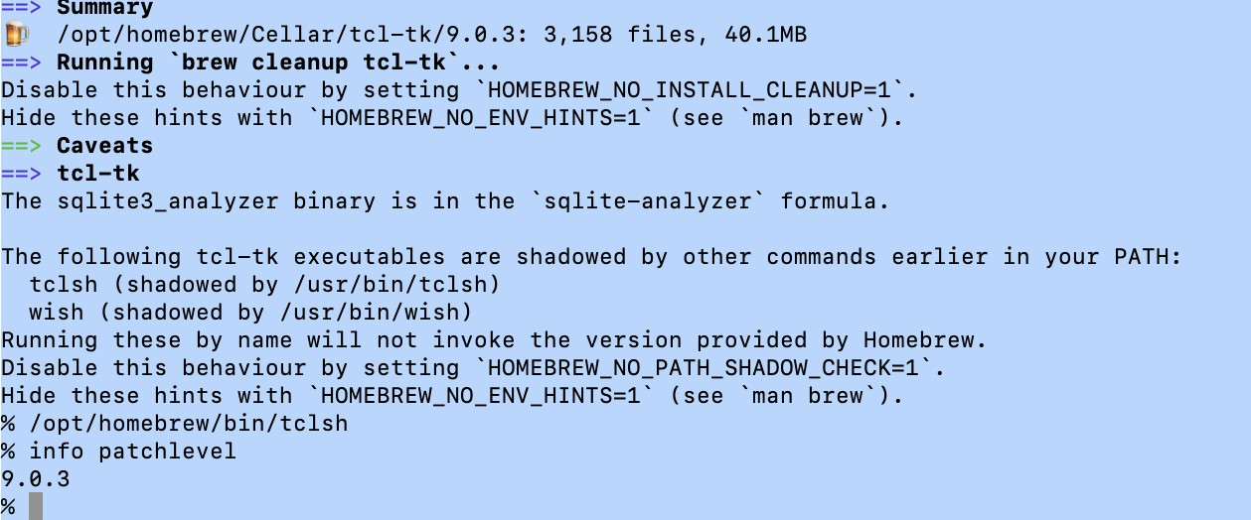


After opening the openroad and executing these commands
  - run_synthesis
  - run_floorplan
  - run_placement
  - run_cts
  - run_routing
We get the total wire length of design as: 1778071958
Clock wire length will be approximately 10% of total wire length:
0.1*1778071958=
177807195.8
Data wire length = Wire length - Clock wire: 1778071958- 177807195.8= 1,60,02,64,762.2

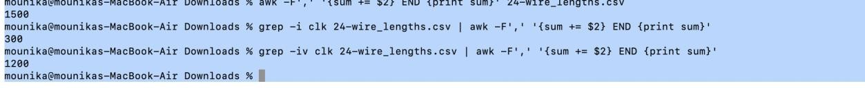

- Worst IR drop and Percentage Degradation
The script to run is:
  - cd /openlane/designs/spm/runs/openlane_test/reports/signoff
  - ls
  - ls | grep -i "pwr"
  - head -20 32-irdrop-VPWR.rpt
  - $awk -F',''{print $NF}' 32-irdrop-VPWR.rpt | head



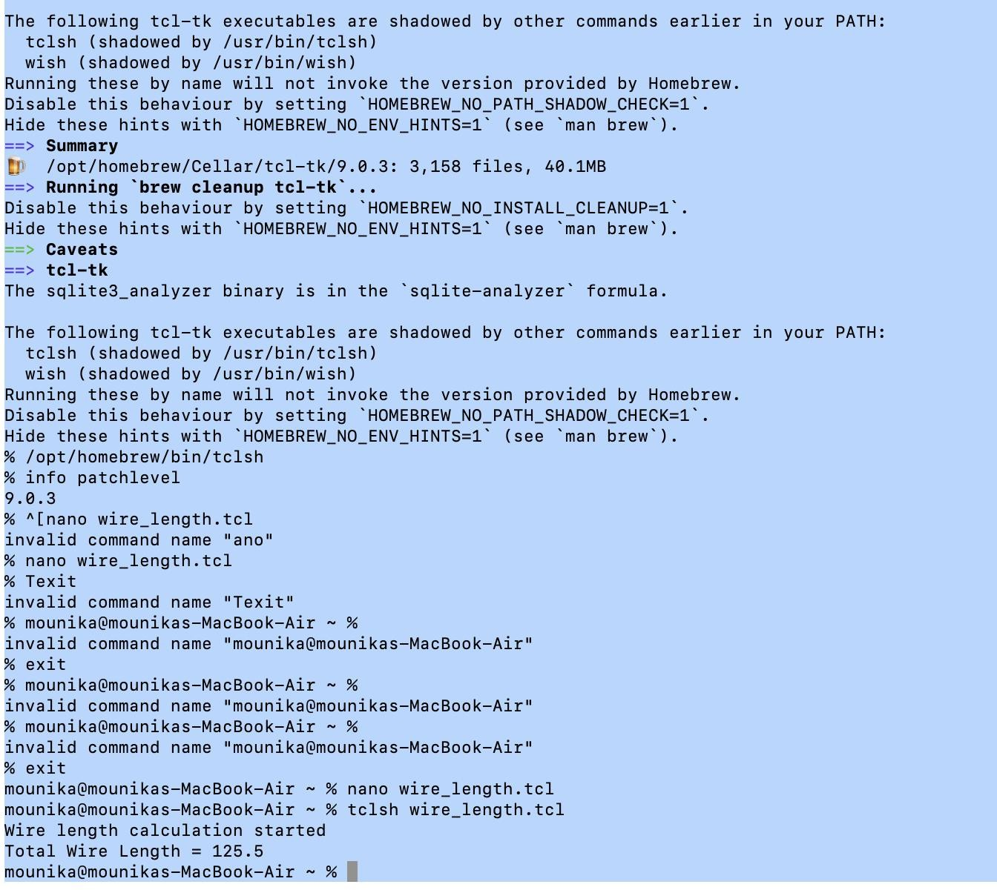


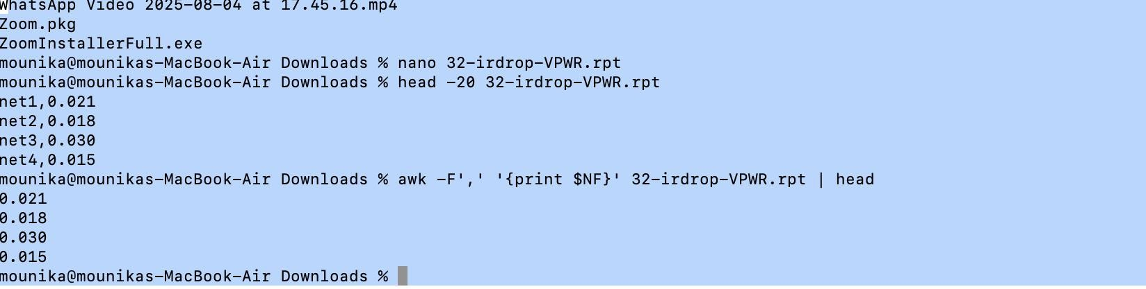

This gives us the voltages, and we can use the lowest voltage for the worst IR drop
  - From observation the lowest voltage is 1.79972
  - IR Drop can be calculated using the formula: Actual voltage (VDD) – Lowest
voltage
  - Sky130 technology uses 1.8 V as nominal supply voltage. This is a standard
defined by the PDK, not in design config.
  - Then the worst IR drop is: 1.8 V – 1.79972 = 0.00028 V
  - To find Percentage Degradation we use: (IR Drop/VDD) * 100
  - Then, the percentage Degradation is (0.00028/1.8) * 100 = 0.01555555%


- Top 10 cells receiving less voltage of both VDD and VSS The script used to get the top 10 cells receiving less voltage including both VDD
and VSS:
  - cd Openlane/OpenLane
  - make mount
  - cd /openlane/designs/spm/runs/openlane_test/reports/signoff
  - ls | grep -i "pwr"
  - ls | grep -i "VGND"
  - head -20 32-irdrop-VPWR.rpt
  - head -20 32-irdrop-VGND.rptInnovation & Entrepreneurship Hub for Educated Rural Youth (SU

The IR-drop analysis shows that the design has very small voltage degradation on both VPWR
and VGND rails. The minimum VPWR observed is approximately 1.79971 V, while the
maximum VGND bounce observed is approximately 0.000356275 V. Hence the power
distribution network is stable and reliable.Innovation & Entrepreneurship Hub for Educated Rural Youth (SURE Trust – IERY)


